# Compute

## EC2

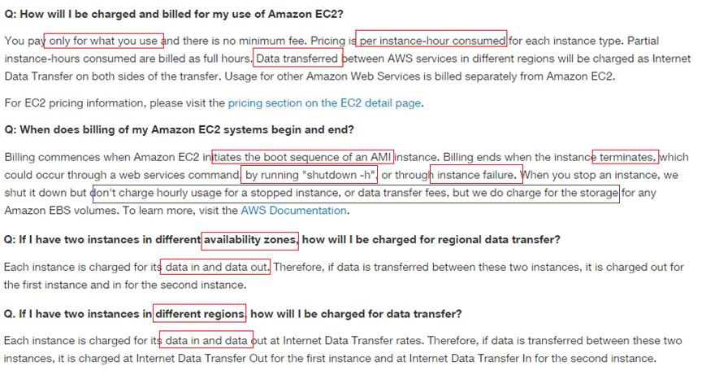

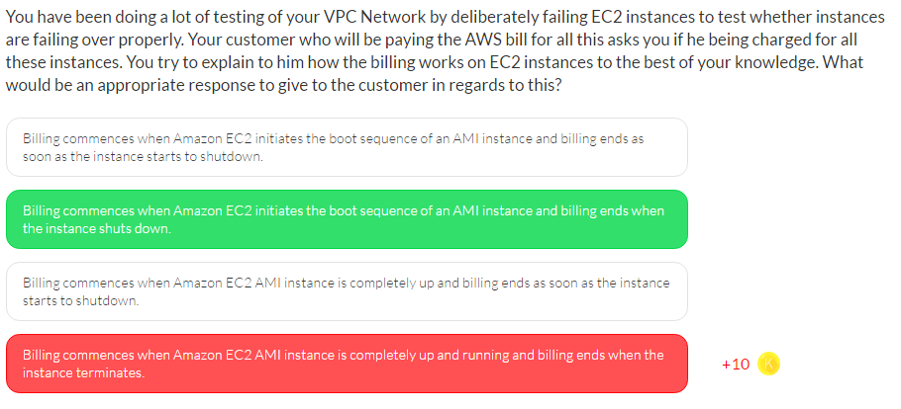

# Storage

## S3

Based On

* Storage
* Request
* Data Transfer

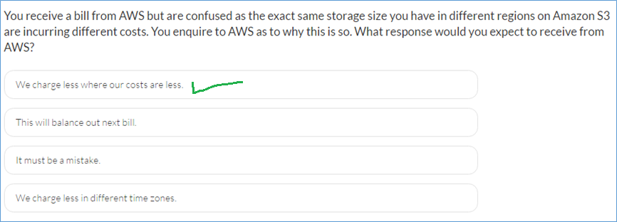



## Cloud Front

Amazon CloudFront billing is mainly affected by

* Dedicated IP SSL Certificates
* Data Transfer Out
* HTTP/HTTPS Requests
* Invalidation Request

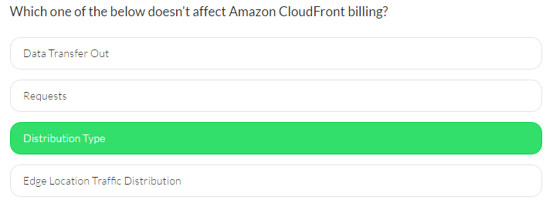

## Storage Gateway

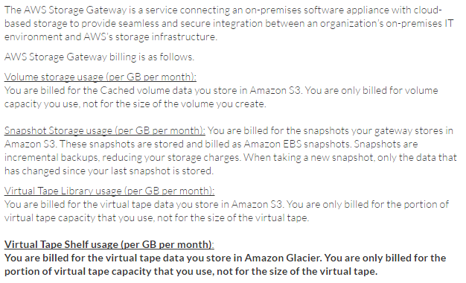

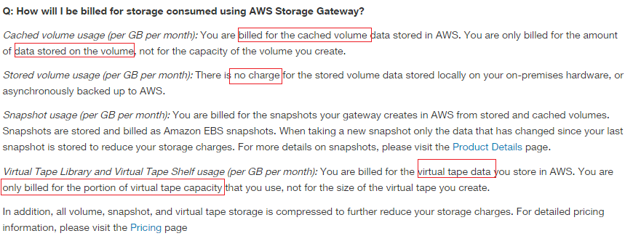

# Database

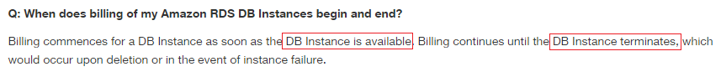

# Networking

# Management

# Security

# Analytics

# Application